**Program : To Read Line**

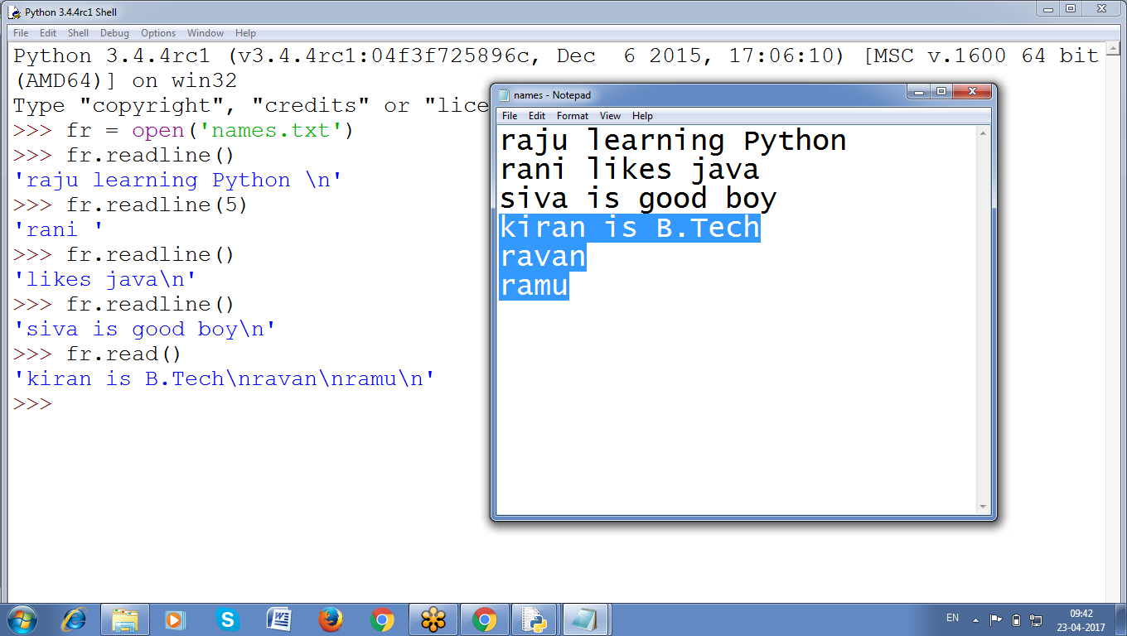

>>> fr = open('names.txt')

>>> fr.readline()

'raju learning Python \n'

>>> fr.readline(5)

'rani '

>>> fr.readline()

'likes java\n'

>>> fr.readline()

'siva is good boy\n'

>>> fr.read()

'kiran is B.Tech\nravan\nramu\n'

>>>

>>> fr.readline()

'anand learning Python\n'  **# First line**

>>> fr.readline()

'jeevan knows django\n' **# Second Line**

>>> **fr.readline(5)** # **Third line 5 chars**

'ramu '

>>> fr.readline() # T**hird line Remaining Characters**

"don't know java\n"

>>>

**Program :: Read all LINES using Readlines()**

>>> fr = open('d:\\myfold\\names.txt', 'r')

>>> fr.readlines()

['anand learning Python\n', 'jeevan knows django\n', "ramu don't know java\n"]

>>> fr.readline()

''

>>>

open(), read(), readline(), readlines()

## **Writing to Files**

* Python allows to write content **to a file** in a way similar to how the print() function “writes” strings **to the screen**
* To Write onto a file need to open in “**write plaintext”** mode or “**append plaintex**t” mode, or *write mode* and *append mode*
* Write mode will **overwrite the existing file** and start from scratch, just like **overwrite a variable’s value with a new value**. Pass **'w'** as the second argument to open() to open the file in write mode. Append mode, will append text to the end of the existing file.
* If the filename passed to open() **does not exist,** both write and append mode **will create a new, blank file.**

>>> fw = open('names2.txt', 'w')

>>> name = input('ENter name ')

ENter name raju

>>> fw.write(name)

4

>>> fr = open('names2.txt')

>>> print(fr.read())

>>>

**TO Change Current file cursor or Find Current Cursor Position**

**Change c**urrent file cursor (position) using the **seek()** method.

Similarly, the **tell()** method returns our current position (in number of bytes).

>>> fr = open('c:\\python34\\names.txt')

>>> fr.tell()

0

>>> fr.read()

'raju learning Python \nrani likes java\nsiva is good boy\nkiran is B.Tech\nravan\nramu\n'

>>> fr.tell()

88

>>>

>>> fr = open('c:\\python34\\names.txt')

>>> fr.seek(10)

10

>>> fr.tell()

10

**>>> fr.read()**

'ing Python \nrani likes java\nsiva is good boy\nkiran is B.Tech\nravan\nramu\n'

>>>

>>> fr = open('c:\\python34\\names.txt')

>>> fr.read(5)

'raju '

>>> fr.readline()

'learning Python \n'

>>> fr.readline(6)

'rani l'

>>> fr.readline()

'ikes java\n'

>>> fr.readlines()

['siva is good boy\n', 'kiran is B.Tech\n', 'ravan\n', 'ramu\n']

>>>

**# Read data from a file line by line and print number of lines**

**# Read Data from a file and print number of lines existing**

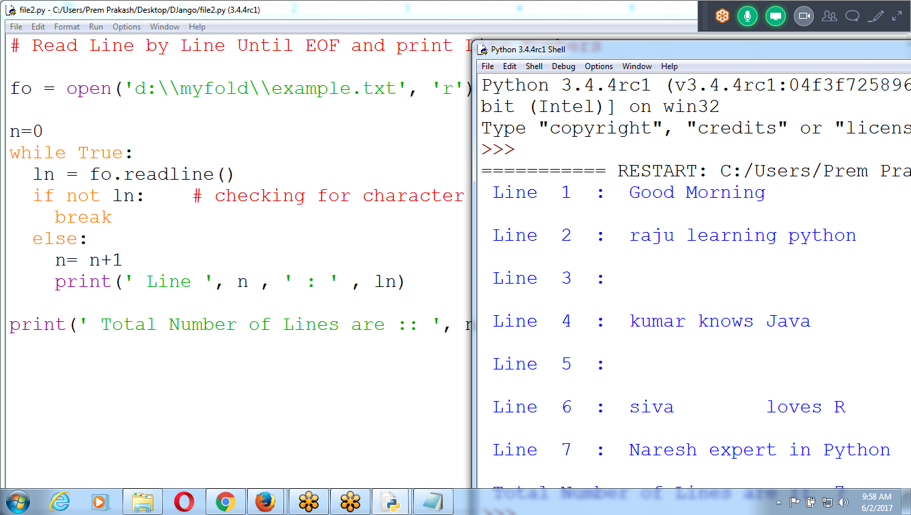

# Read Line by Line Until EOF and print Line Numbers

fo = open('d:\\myfold\\example.txt', 'r')

n=0

while True:

ln = fo.readline()

if **not ln**: # checking for character

break

else:

n= n+1

print(' Line ', n , ' : ' , ln)

print(' Total Number of Lines are :: ', n)

**# SEarch for a string in a file using while LOOP**

**Search for given string in a file and print Line number**

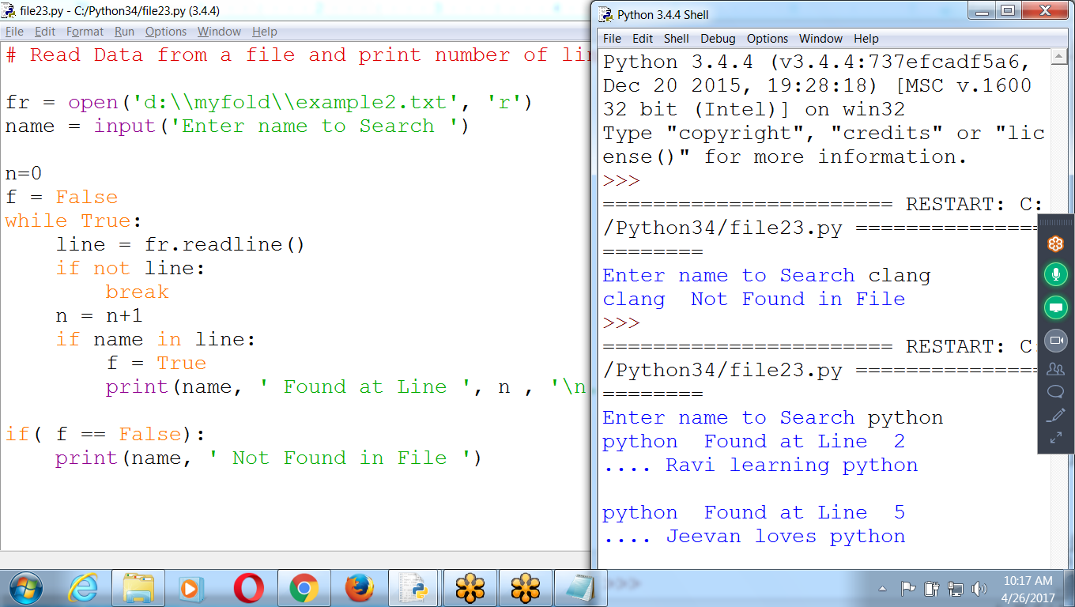

**# Read Data from a file and print number of lines existing**

**fr = open('d:\\myfold\\example2.txt', 'r')**

**name = input('Enter name to Search ')**

**n=0**

**f = False**

**while True:**

**line = fr.readline()**

**if not line:**

**break**

**n = n+1**

**if name in line:**

**f = True**

**print(name, ' Found at Line ', n , '\n....', line)**

**if( f == False):**

**print(name, ' Not Found in File ')**

**# SEarch for a string in a file using FOR Loop**

**while True:**

**line = fr.readline()**

**if not line:**

**break**

**(or) for line in fr:**

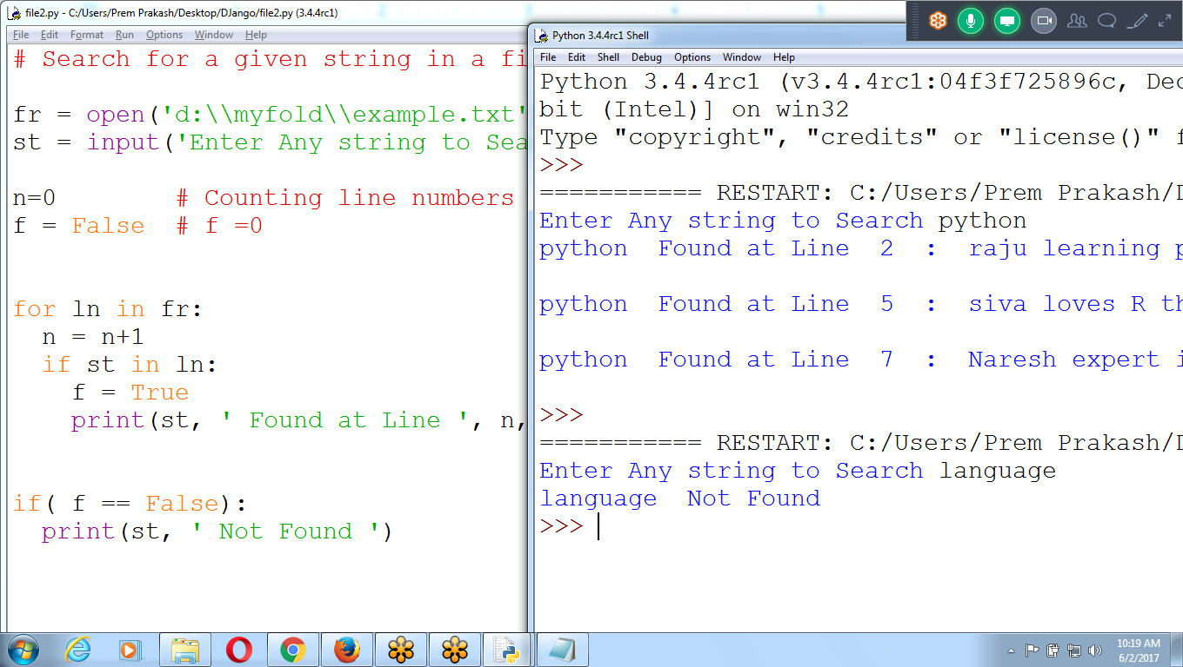

**# Search for a given string in a files and Count occurrences**

**fr = open('d:\\myfold\\example.txt')**

**st = input('Enter Any string to Search ')**

**n=0 # Counting line numbers**

**f = False # f =0**

**for ln in fr:**

**n = n+1**

**if st in ln:**

**f = True**

**print(st, ' Found at Line ', n, ' : ', ln)**

**if( f == False):**

**print(st, ' Not Found ')**

**fr = open('d:\\myfold\\example2.txt', 'r')**

**name = input('Enter name to Search ')**

**n=0**

**f = False**

**for ln in fr:**

**n = n+1**

**if name in ln:**

**f = True**

**print(name, ' Found at Line ', n , '\n....', ln)**

**if( f == False):**

**print(name, ' Not Found in File ')**

**Using FOR loop**

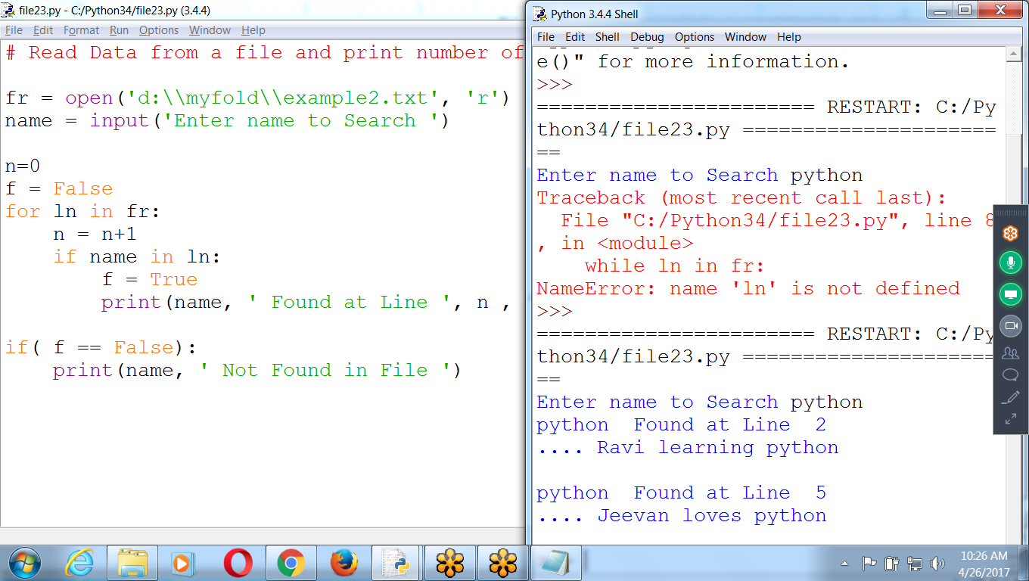

**Program to Merge names and Body Files onto NEW file**

**File 1: Names.txt file1 : read**

**File 2 : Body.txt file2 : read**

**File 3 : Include Names with body f3: write**

**Existing Files**

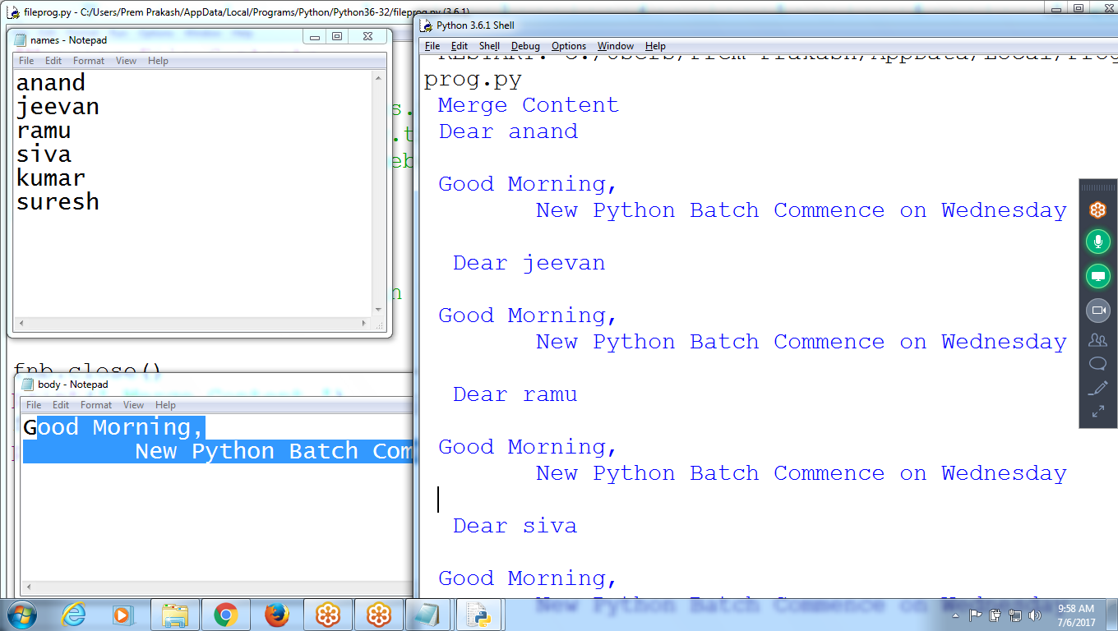

**Output File : namesbody**

**To Write onto a file**

**#Merging File Contents**

**fn = open('d:\\myfold\\names.txt', 'r')**

**fb = open('d:\\myfold\\body.txt', 'r')**

**fnb = open('d:\\myfold\\namebody.txt', 'w')**

**st = fb.read()**

**for ln in fn:**

**mes = ' Dear ' + ln + ' \n ' + st + ' \n '**

**fnb.write(mes)**

**fnb.close()**

**print(' Merge Content ')**

**fnb = open('d:\\myfold\\namebody.txt', 'r')**

**print(fnb.read())**

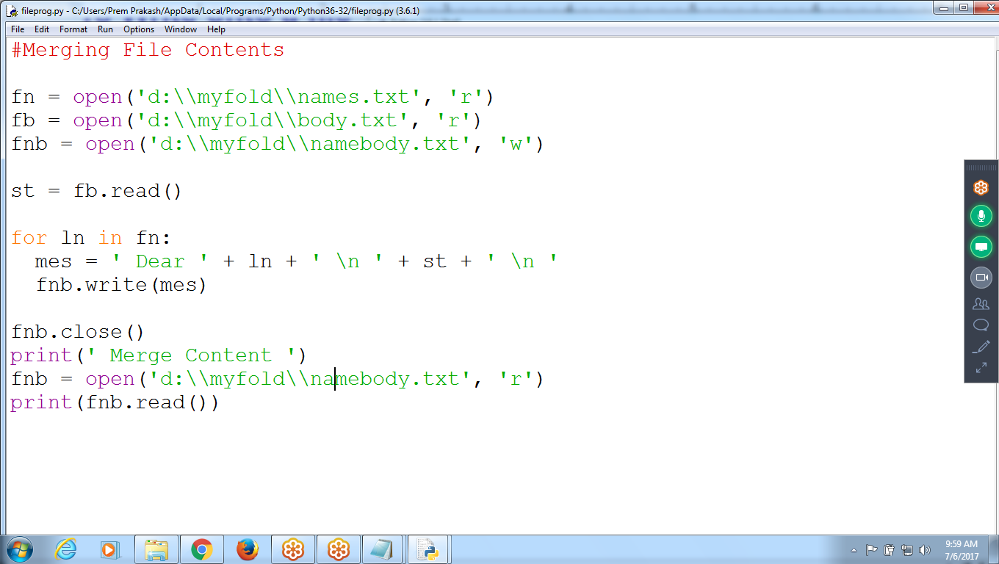

**# Merging Files**

**# F1 : Reading Names, F2 : Body, F3 : Merging**

**fn = open('d:\\myfold\\mynames.txt', 'r')**

**fb = open('d:\\myfold\\body.txt', 'r')**

**fnb = open('d:\\myfold\\mynamesbody.txt', 'w')**

**bod = fb.read()**

**for na in fn:**

**st = 'Dear ' + na + '\n' + bod + '\n\n'**

**fnb.write(st)**

**fn.close()**

**fb.close()**

**fnb.close()**

**print('Merge Content : ')**

**fnb = open('d:\\myfold\\mynamesbody.txt', 'r')**

**print(fnb.read())**

## 

**OS Operations**

## **The *getcwd()* Method**

The *getcwd()* method displays the current working directory.

### **Syntax**

os.getcwd()

### **Example**

Following is the example to give current directory −

import os  
# This would give location of the current directory  
os.getcwd()

## **>>> import os**

## **>>> os.getcwd()**

## **'C:\\Python34'**

## **>>>**

## **>>> import os**

## **>>> os.getcwd()**

## **'C:\\Users\\Prem Prakash\\AppData\\Local\\Programs\\Python\\Python36-32'**

## 

## 

## 

## 

## **The *chdir()* Method**

You can use the *chdir()* method to change the current directory. The chdir() method takes an argument, which is the name of the directory that you want to make the current directory.

### **Syntax**

os.chdir("newdir")

### **Example**

Following is the example to go into "/home/newdir" directory −

import os  
os.chdir("/home/newdir")

## 

## 

## **>>> import os**

## **>>> os.getcwd()**

## **'C:\\Users\\Prem Prakash\\AppData\\Local\\Programs\\Python\\Python36-32'**

## **>>> os.chdir('d:\\myfold')**

## **>>> os.getcwd()**

## **'d:\\myfold'**

## **>>>**

## 

## 

## **Use backward ‘/’ to change**

Currently in D:\\myfold

**On pressing ‘/” moves “Root Directory” i.e D:**

## 

## **Moves to D:drive**

## 

## 

## **To move to Previous Directory use : ‘../’**

Currently in : d:\\myfold

On specifiing : **‘../’**  **moves to one directory back**

## 

## 

## **‘/’ : Moves to Directly to Parent Drive**

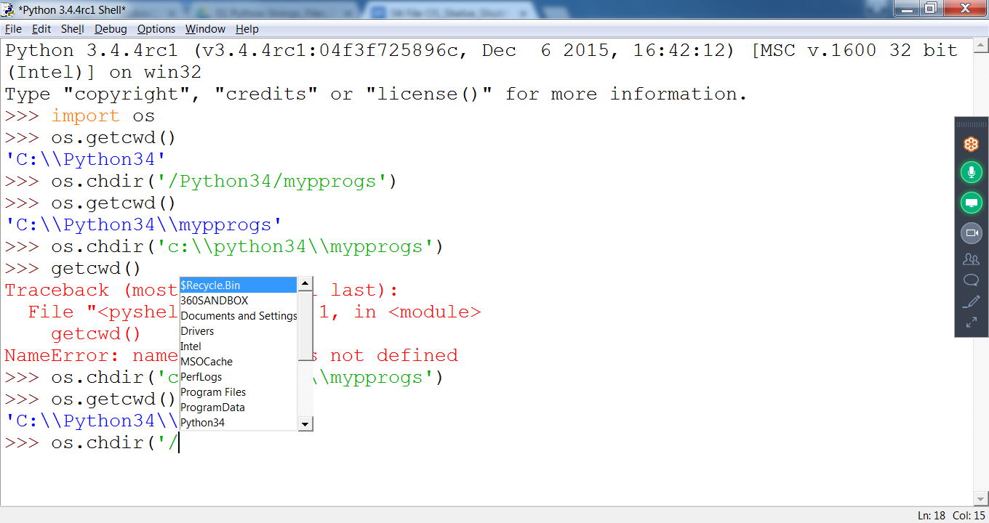

Currently in c:\intel\logs

On specifing : ‘/’ moves to ROOT

## 

## 

## 

## **Currently c:\\intel\logs**

Specify : ‘../ ‘ Moves to intel folder

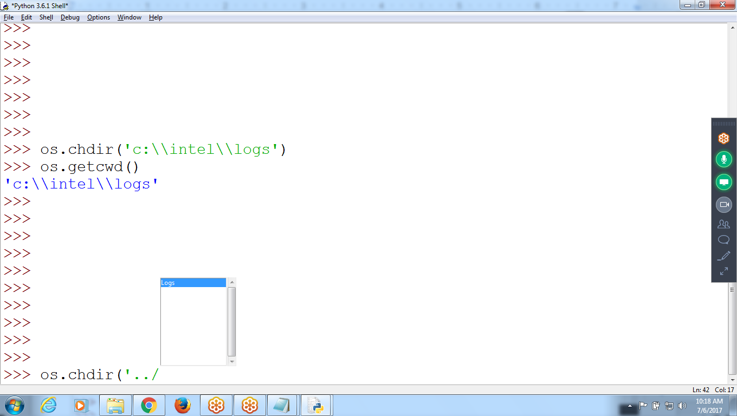

## 

## **>>> os.getcwd()**

## **'c:\\python34\\mydir'**

## **>>> os.chdir('/')**

## **>>> os.getcwd()**

## **'c:\\'**

## 

## 

## **>>> os.chdir('c:\\python34\\mydir')**

## **>>> os.getcwd()**

## **'c:\\python34\\mydir'**

## **>>> os.chdir('../Scripts')**

## **>>> os.getcwd()**

## **'c:\\python34\\Scripts'**

## **>>>**

## 

## 

## **os.getcwd() : get current working directory**

os.chdir() : changing directory using / or ../

## 

## 

## **Renaming and Deleting Files**

Python **os** module provides methods that help you perform file-processing operations, such as renaming and deleting files.

To use this module you need to import it first and then you can call any related functions.

## **The rename() Method**

The *rename()* method takes two arguments, the current filename and the new filename.

### **Syntax**

os.rename(current_file_name, new_file_name)

### **Example**

Following is the example to rename an existing file *test1.txt*:

import os  
# Rename a file from test1.txt to test2.txt  
os.rename( "test1.txt", "test2.txt" )

>>> **os.rename('names.txt', 'nas.txt')**

Traceback (most recent call last):

File "<pyshell#0>", line 1, in <module>

os.rename('names.txt', 'nas.txt')

NameError: name 'os' is not defined

**>>> import os**

>>> os.rename('names.txt', 'nas.txt')

>>> fr = open('names.txt')

Traceback (most recent call last):

File "<pyshell#3>", line 1, in <module>

fr = open('names.txt')

FileNotFoundError: [Errno 2] No such file or directory: 'names.txt'

**>>> fr = open('nas.txt')**

>>> print(fr.read())

HARSH

Nihaar

chaitu

Anand

>>>

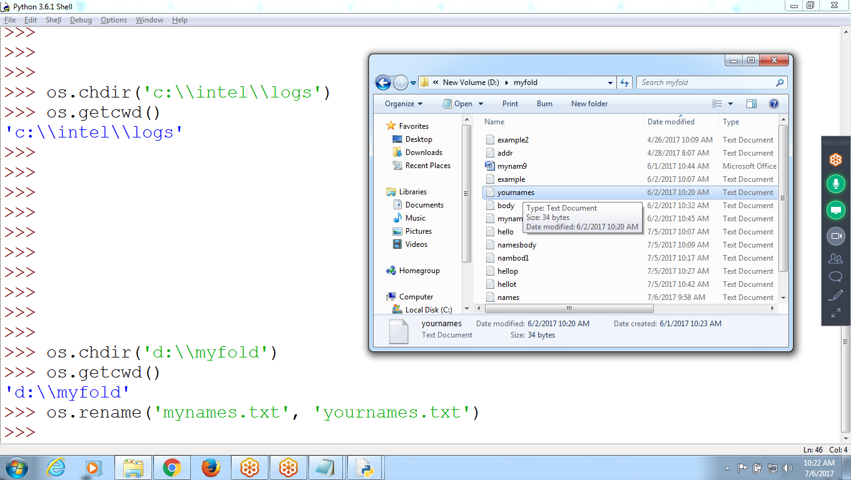

## 

## 

## **The *remove()* Method**

You can use the *remove()* method to delete files by supplying the name of the file to be deleted as the argument.

### **Syntax**

os.remove(file_name)

### **Example**

Following is the example to delete an existing file *test2.txt* −

**Removing filename ‘yournames.txt’**  
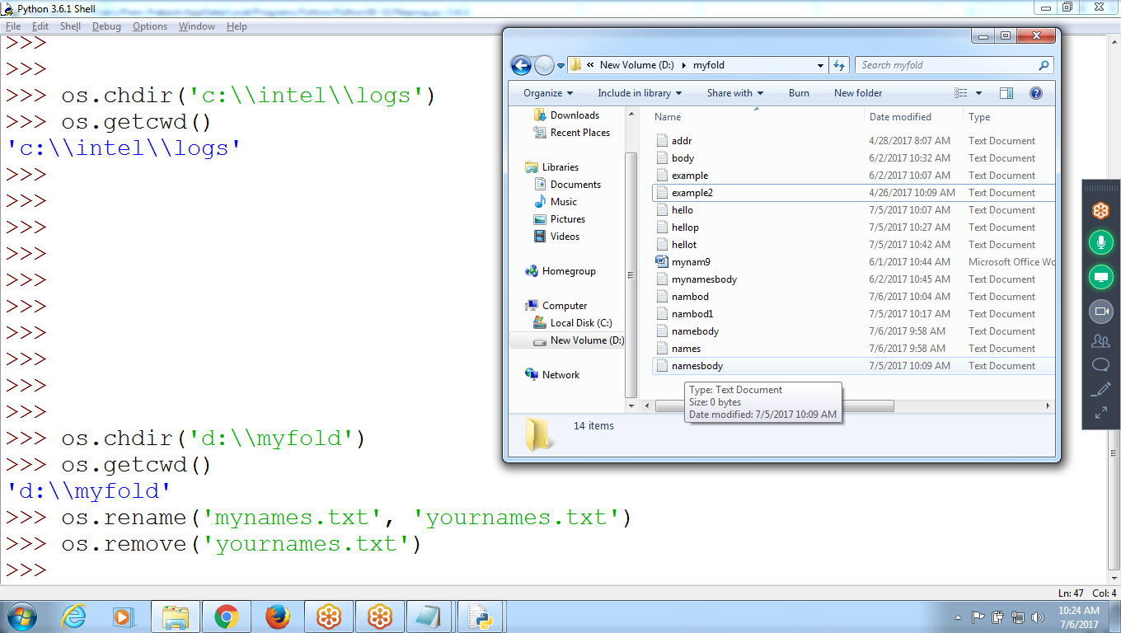

**>>> import os**

## **>>> os.remove('nas.txt')**

## **>>> fr= open('nas.txt')**

## **Traceback (most recent call last):**

## **File "<pyshell#2>", line 1, in <module>**

## **fr= open('nas.txt')**

## **FileNotFoundError: [Errno 2] No such file or directory: 'nas.txt’**

## **>>>**

## 

**Files related : os.rename(), os.remove()**

## 

************************************************************************************************************************

*************************************************************************************************************************